**Software Requirements**

**Specification**

**for**

**Apelo Dental Clinic Management System**

**Version 1.0 approved**

**Prepared by Progmatiks**

**Asia Pacific College**

**November 23, 2023**

***Copyright © 1999 by Karl E. Wiegers. Permission is granted to use, modify, and distribute this document.***

# Table of Contents

Table of Contents 2

Revision History 2

1. Introduction 1

1.1 Purpose 1

1.2 Document Conventions 1

1.3 Intended Audience and Reading Suggestions 1

1.4 Product Scope 1

1.5 References 1

2. Overall Description 2

2.1 Product Perspective 2

2.2 Product Functions 2

2.3 User Classes and Characteristics 2

2.4 Operating Environment 2

2.5 Design and Implementation Constraints 2

2.6 User Documentation 2

2.7 Assumptions and Dependencies 3

3. External Interface Requirements 3

3.1 User Interfaces 3

3.2 Hardware Interfaces 8

3.3 Software Interfaces 8

3.4 Communications Interfaces 8

4 System Features 9

4.1 Manage Report 9

4.2 Manage Inventory 9

4.3 Manage Queueing 9

4.4 Manage Account 9

4.5 Manage Dental Records 9

4.6 Manage Dentist Schedule 10

5 Other Nonfunctional Requirements 10

5.1 Performance Requirements 10

5.2 Security Requirements 10

5.3 Software Quality Attributes 10

5.4 Business Rules 10

Appendix A: Glossary 10

Appendix B: Analysis Models 11

# Introduction

## Purpose

The purpose of this document is to provide a detailed description of the requirements for ADENICSY (Apelo Dental Clinic Management System). It will explain the purpose and features of the system, the intended audience, and the reading suggestions.

## Document Conventions

This document follows the IEEE 830-1998 standard for software requirements specifications.

## Intended Audience and Reading Suggestions

This document is intended for the development team, stakeholders, and anyone else who is interested in the development of ADENICSY (Apelo Dental Clinic Management System). It is recommended that the reader has a basic understanding of software development and dental clinic management.

## Product Scope

ADENICSY (Apelo Dental Clinic Management System) is a product that will be used to manage the day-to-day operations of a dental clinic. The system will include features such as same-day visitation, patient management, billing, and reporting.

*Scope:*

*The focus of this project is to lessen the waiting time of the patients of ADENICSY (Apelo Dental Clinic Management System) and digitalize the manual processing of patient’s information. This will include features such as user login, inputting patient information from different users, queueing management, inventory management, email verification, search function and recording payments information of the patient. Furthermore, the types of testing that will be conducted will be enumerated, the specific components that will be tested*

* *Functional Testing: This will ensure that all the website's features and functionalities, such as navigation, form submissions, and user interactions, are working as intended.*

* *Usability Testing: To evaluate the user-friendliness of the website, ensuring that visitors can easily navigate through the pages and accomplish their goals.*

* *Compatibility Testing: Checking the website's compatibility with various browsers (e.g., Chrome, Firefox, Safari) and devices (desktop, and mobile) to guarantee a consistent user experience.*

* *Acceptance Testing: To test if the system meets the user’s needs.*

## References

*This document references the following documents:*

* *IEEE 830-1998 Standard for Software Requirements Specifications*

# Overall Description

## Product Perspective

ADENICSY (Apelo Dental Clinic Management System) will be a standalone software product that will be installed on a local server. It will be designed to integrate with other software products used by the dental clinic.

## Product Functions

ADENICSY (Apelo Dental Clinic Management System) will include the following functions:

* Scheduling
* Patient management
* Billing
* Reporting
* Inventory

## User Classes and Characteristics

ADENICSY (Apelo Dental Clinic Management System) will be used by the following user classes:

* Staff
* Dentists
* Owner
* Patients

## Operating Environment

ADENICSY (Apelo Dental Clinic Management System) will be installed on a local server running Windows 10. It will require a minimum of 8GB of RAM and 500GB of storage.

## Design and Implementation Constraints

ADENICSY (Apelo Dental Clinic Management System) is developed with the use of Visual Studio Code, updated using GitHub, tested on localhost servers using XAMPP and currently hosted using APC Cloud.

## User Documentation

ADENICSY (Apelo Dental Clinic Management System) *will include user documentation that will be available in both digital and print formats. The documentation will include instructions on how to use the system and troubleshoot common issues.*

## Assumptions and Dependencies

ADENICSY (Apelo Dental Clinic Management System) is dependent on the hosting, which is currently on the APC (Asia Pacific College) Cloud but should be transferred to another hosting server such as GoDaddy.

# External Interface Requirements

## User Interfaces

The user interface of ADENICSY (Apelo Dental Clinic Management System) will be designed to be intuitive and easy to use. It will include features such as a welcome screen, login and signup, scheduling, inventory management, dashboard, payment, and a patient homepage.

### 3.1.1 User Interfaces for Patient

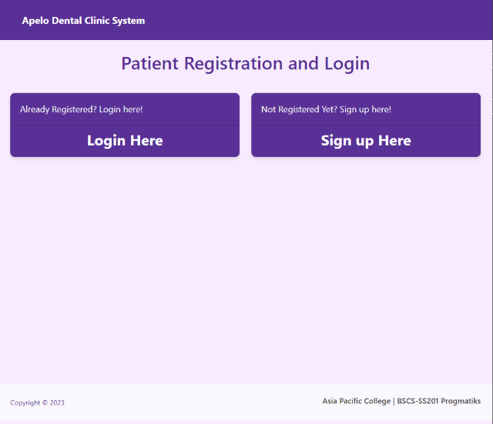

### A screenshot of a computer Description automatically generated3.1.2 User Interfaces for Staff

### 3.1.3 User Interfaces for Dentist

**User Interfaces for Admin

## 3.2 Hardware Interfaces

ADENICSY (Apelo Dental Clinic Management System) will require a keyboard and mouse for input. It will also require a printer for printing reports and patient information.

## 3.3 Software Interfaces

ADENICSY (Apelo Dental Clinic Management System) will be designed to integrate with other software products used by the dental clinic, such as accounting software and electronic health records.

## 3.4 Communications Interfaces

ADENICSY (Apelo Dental Clinic Management System) *will not require any external communication interfaces.*

# System Features

## Manage Report

### Admin

Within the admin dashboard, the admin can edit users, manage inventory, search for patients, and view reports of the clinics’ performance.

## Manage Inventory

### 4.2.1 Admin

The admin can manage the inventory of the clinics’ supplies, view critical levels, modifications, while also being able to add, update and delete specific items.

### Staff

The staff can view the supplies of the inventory.

### Patient

Patient and payment records are stored in the inventory system of ADENICSY.

## Manage Queueing

### Patient

The patient can queue up online for a scheduled visit to the clinic. The patient can also refresh the number to update the current number being served. Patients can choose their preferred dentist.

### Staff

The staff can manage the queueing of patients regarding their status and confirmation of visit. Staff can also reset the queueing number and download queueing list.

## Manage Account

### *Patient*

The patient can open the website and click the proceed to patient portal. Once redirected, the patient can either sign up for a new account or log-in if the patient is an existing user. The patient can also manage their account information on the profile tab.

### *Admin*

The admin can edit the profile of its users such as the staff and patients while also having the ability to delete its users. The admin can also add new employees and search for specific users. The admin can also change their own password.

### *Dentist/Staff*

The dentist can update the credentials or login information such as change password, name and contact information.

## Manage Dental Records

### *Dentist/Staff*

The dentist can provide notes after the procedures, upload x-ray files, and add new patient information.

## 4.6 Manage Dentist Schedule

### *4.6.1 Staff*

The staff can update the slots of the website’s calendar where the dentist can add/confirm their schedule.

### *4.6.2 Dentist*

The dentist can modify their availability/schedule.

Manage Payment Records

### 4.6.3 Patients

The patients can view and refresh their payment history.

### 4.6.4 Staff

The staff can update the payment of the patients after procedure and updates payment balances.

### 4.6.5 Dentist

The dentist can add new payment details of the patients after the procedures.

# Other Nonfunctional Requirements

## Performance Requirements

*The system should respond to user requests within 2 seconds.* Safety Requirements

The system should protect patient data from unauthorized access and data breaches.

## Security Requirements

The system should protect patient data from unauthorized access and data breaches.

## Software Quality Attributes

* Usability: The system should be easy to use and navigate for all user classes.
* Scalability: The system should be able to handle an increase in users or workload without significant performance degradation.
* Reliability: The system should be available 24/7 with a maximum downtime of 1 hour per month.

## Business Rules

The system should only allow authorized personnel to access patient data.

# Appendix A: Glossary

* *ADENICSY – Apelo Dental Clinic Management System*
* *APC – Asia Pacific College*
* *localhost – Database/table storage*
* *XAMPP – localhost server for web application testing*
* *Cloud – A virtual server*

# Appendix B: Analysis Models

